Employee Attrition: Identifying Critical Tenure Periods and Contributing Risk Factors

In this project we focus on employee tenure in a company. Specifically, we are investigating the tenure period where attrition spikes as well as some factors that may shed light on why some employees left the company. The aim is for the company to improve employee retention. The dataset is from IBM

Business Question
Is there a “danger zone “tenure period where attrition spikes, and what are some factors related to attrition?

Key Findings
- Newer employees are more likely to leave the company at a higher rate than older employees. Furthermore, the ages with the highest attrition rates were in between 27 and 35, which indicates that workers in their late 20s and early 30s were more prone to attrition.
- A poor working environment, low job involvement, job dissatisfaction and an unhealthy work life balance where disproportionately associated with employees who left the company.

Visual Key Findings

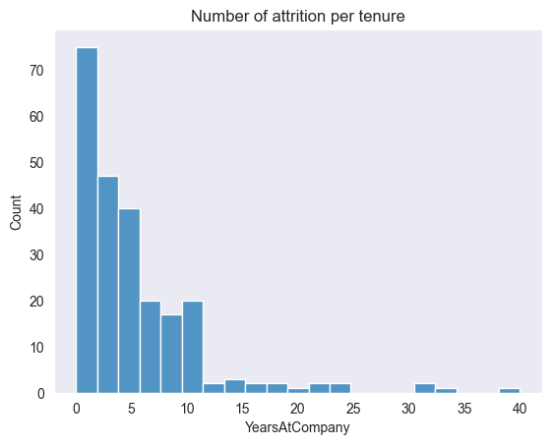
Majority of employees who left the company where at the company for 10 years or less.

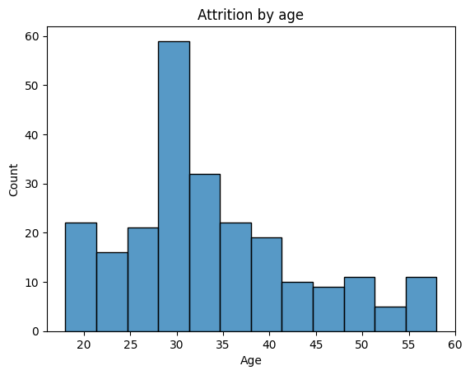
Employees aged between 25 and 35 were among the highest to leave the company.

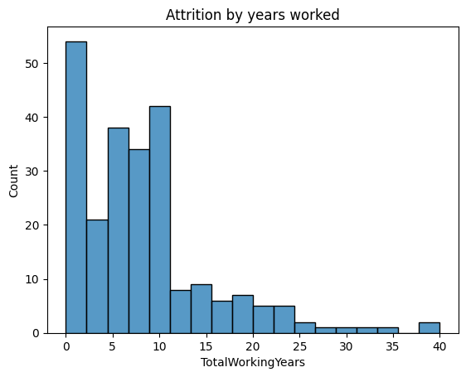
Majority of employees who left the company were early career starters.
Recommendations
In order to incentivise employees to stay longer in the company, managers can ensure a positive work environment, such as job satisfaction and promoting a healthy work-life balance, for newer employees. Furthermore, managers can also ensure that newer employees are tasked with projects that foster the utilisation of a diverse set of skills instead of highly repetitive and monotone tasks; this improves job involvement.

